Develop AI agents with the Microsoft Foundry extension in Visual Studio Code
- YT Video for demo: https://www.youtube.com/watch?v=0Yv9VomcmnQ
- Get started with the Microsoft Foundry extension
  - This extension provides direct access to the capabilities of Microsoft Foundry's Agent Service without leaving your code editor, streamlining the entire agent development workflow.
  - The Microsoft Foundry for Visual Studio Code extension is a powerful tool that brings enterprise-grade AI agent development capabilities directly into Visual Studio Code. It provides an integrated experience for:
    - Agent Discovery and Management - Browse, create, and manage AI agents within your Microsoft Foundry projects
    - Visual Agent Designer - Use an intuitive interface to configure agent instructions, tools, and capabilities
    - Integrated Testing - Test agents in real-time using the built-in playground without switching contexts
    - Code Generation - Generate sample integration code to connect agents with your applications
    - Deployment Pipeline - Deploy agents directly to Microsoft Foundry for production use
  - 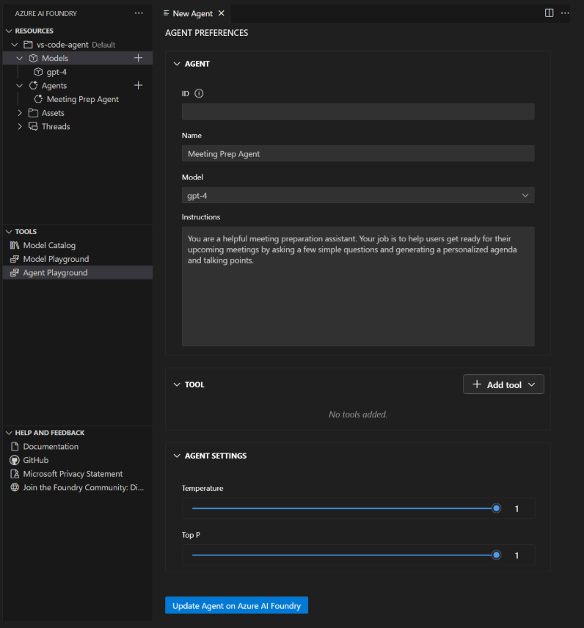
  - Key features and capabilities:
    - Agent Designer Interface: A visual designer that simplifies agent creation and configuration. You can define agent instructions, select appropriate models, and configure tools through an intuitive graphical interface.
    - Built-in Playground: An integrated testing environment where you can interact with your agents in real-time, test different scenarios, and refine agent behavior before deployment.
    - Tool Integration:
      - RAG (Retrieval-Augmented Generation) for knowledge-based responses
      - Search capabilities for information retrieval
      - Custom actions for specific business logic
      - Model Context Protocol (MCP) servers for extended functionality
    - Project Integration: Direct connection to your Microsoft Foundry projects, allowing you to work with existing resources and deploy new agents to your established infrastructure.
- Develop AI agents in Visual Studio Code:
  - Creating a new agent:
    - Open the Microsoft Foundry Extension view in Visual Studio Code
    - Navigate to the Resources section
    - Select the + (plus) icon next to the Agents subsection to create a new AI agent
    - Configure the agent properties in the Agent Designer view that opens
    - 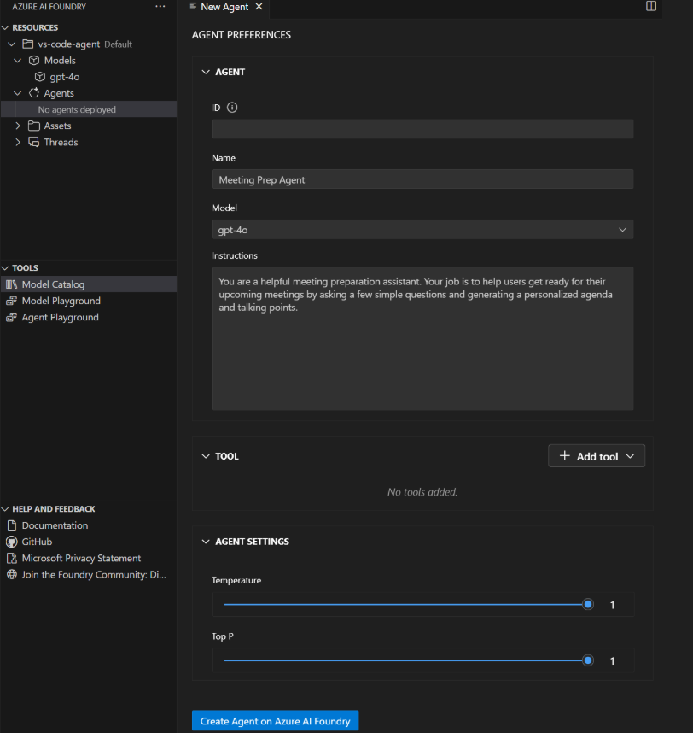
    - Your AI agent is defined in a YAML file that contains all configuration details. Here's an example structure:
    - 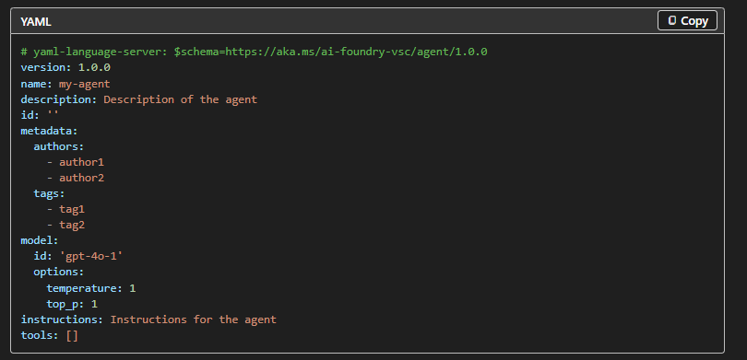
  - Managing deployed agents
    - After deployment, you can
      - View agent details - Select the deployed agent to see the Agent Preferences page
      - Edit the agent - Select "Edit Agent" to modify configuration and redeploy with the Update on Microsoft Foundry button
      - Generate integration code - Select "Open Code File" to create sample code for using the agent
      - Test in playground - Select "Open Playground" to interact with the deployed agent
  - View agent details - Select the deployed agent to see the Agent Preferences page
  - Edit the agent - Select "Edit Agent" to modify configuration and redeploy with the Update on Microsoft Foundry button
  - Generate integration code - Select "Open Code File" to create sample code for using the agent
  - Test in playground - Select "Open Playground" to interact with the deployed agent
  - When you interact with deployed agents, the system creates threads to manage conversation sessions:
    - Threads - Conversation sessions between an agent and user that store messages and handle context management
    - Messages - Individual interactions that can include text, images, and files
    - Runs - Single executions of an agent that use the agent's configuration and thread messages
  - You can view and manage these threads through the Azure Resources view in the extension.

- Extend AI agent capabilities with tools
  - When an agent determines that a tool is needed to respond to a user request, it can automatically invoke the appropriate tool, process the results, and incorporate them into its response.
  - Built-in tools:
    - Code Interpreter - Enables agents to write and execute Python code for mathematical calculations, data analysis, chart generation, file processing, and complex problem-solving
    - File Search - Provides retrieval-augmented generation by uploading and indexing documents, searching knowledge bases, and supporting various file formats (PDF, Word, text files)
    - Grounding with Bing Search - Allows agents to search the internet for real-time data, current events, and trending topics while providing citations and sources
    - OpenAPI Specified Tools - Connects agents to external APIs and services through OpenAPI 3.0 specifications
    - Model Context Protocol (MCP) - Standardized tool interfaces for extended functionality and community-driven tools
  - 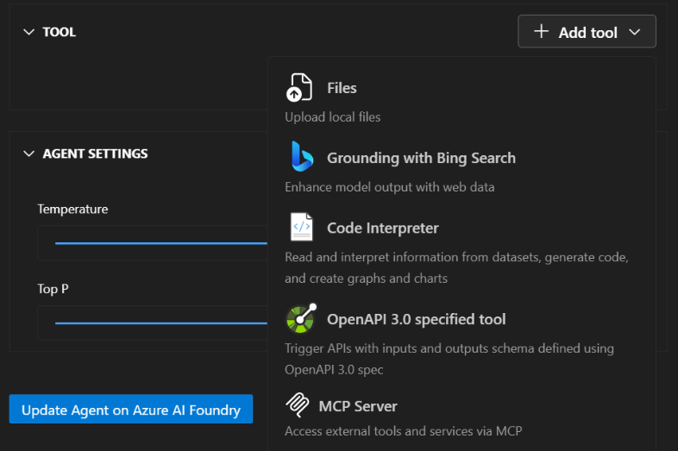
  - MCP servers provide a standardised way to add tools to your agents using an open protocol. This approach enables you to use community-built tools and create reusable components that work across different agent implementations.
  - Key benefits include:
    - Standardized protocol for consistent tool communication
    - Reusable components that work across different agents
    - Community-driven tools available through MCP registries
    - Simplified integration with consistent interfaces
- Exercise - Build an AI agent using the Microsoft Foundry extension
    - https://microsoftlearning.github.io/mslearn-ai-agents/Instructions/07-build-agent-in-vs-code.html
- Module assessment:
  - 